Color Game

 In this game the player has to enter colour of the word that appears on the screen and hence the score increases by one, the total time to play this game is 60 seconds and colours used in this game are Red , Blue , Green , Pink, Black , Yellow , Orange , White , Purple and Brown. The interface will display name of different colours in different colours . User has to identify the colour and enter the correct colour name to win the game .If user enter any wrong name it do nothing and display the next colour word and score remains the same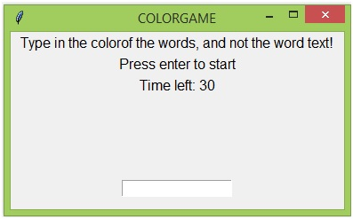

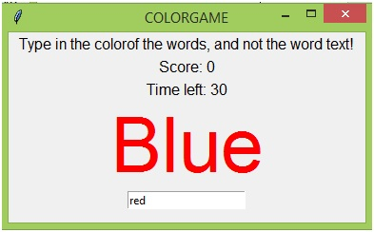

The above two images shows how the user enters the colour of the displayed colour word. In this way the user enters the colour of the word.

V.Jyothirmai

18BQ1A05L5

SK.Nazma Sulthana

18BQ1A05I5